Name of the project : Air tickets reservation application

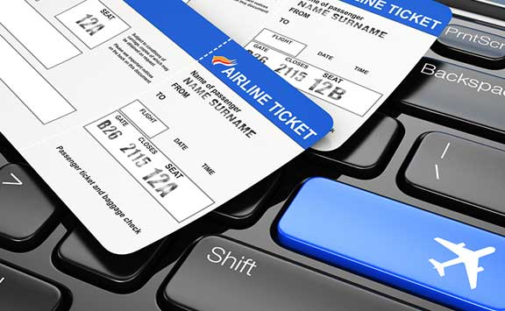

*Description*: This simple project is for the Air Transport Industry in it the passenger choose the destination as selecting the Departure city and the Arrival city , choose the Number of the flight , and the seat in the end of the application a ticket is printed with the following information.

Name of the passenger:

The Departure city:

The Arrival city:

The number of the flight :

The information for the passenger is store, and if he writes his name again the program greetings him, if it is new passenger the program will ask for the rest of the information. When a passenger chooses a specific number of flight and a specific number of seat after him if another passenger tries to choose the same seat number on the same flight. The program will refuse to reserve it.

This project includes   
  
Learning how to install the Java development kit, then move onto creating a project and package and writing and running many Java classes. Is created a scrapbook page, define variables, work with integers and floating point variables, and document project fields. This project covers using the passenger class, writing test methods and the flight class, passing data between objects, storing objects in ArrayLists<>, using the console for user input, and deploying your application. In the end of the project is creating and finishing the subclass and add logging statements. In it are touched three of the four pillars in Object Oriented Programming, namely Polymorphism, Inheritance, Encapsulation , (without) Abstraction. Also the application is built on the principle from Abstraction to Realization.

The application Air tickets reservation is built by Test Driven programming design style involving Agile principles ,and unit testing and test suit ,it is created on Eclipse IDE .Also involved Service Oriented Architecture with the application is attached and JAR file.

The project involved:

* **Introduction**
  + [Introduction To Learning Java 8](javascript:%20void(0);)
* **02. Core Concepts Of Java**
  + [Java Versions](javascript:%20void(0);)
  + [Anatomy Of A Java Program](javascript:%20void(0);)
* **03. Installing A Development Environment**
  + [Installing The JDK And Eclipse For Windows](javascript:%20void(0);)
  + [Installing The JDK And Eclipse For OSX](javascript:%20void(0);)
  + [Installing The JDK And Eclipse For Linux](javascript:%20void(0);)
* **04. First Steps**
  + [Creating A Project And Package](javascript:%20void(0);)
  + [Writing Your First Java Class](javascript:%20void(0);)
  + [Compiling And Running A Java Class](javascript:%20void(0);)
  + [Course Project Class Diagram](javascript:%20void(0);)
* **05. Data Types and Variables - Scrapbook**
  + 0501 Creating A Scrapbook Page
  + 0502 Defining Variables
  + 0503 Working with Integers
  + 0504 Working with Floating Point Variables
  + 0505 Defining Boolean Variables
  + 0506 Defining String Variables
  + 0507 Defining Date Variables
  + 0508 Documenting Out Project Fields
* **06. Anatomy Of A Class**
  + 0601 Class Declaration
  + 0602 Fields And Comments
  + 0603 Constructors
  + 0604 Getter And Setter Methods
  + 0605 Using The Passenger Class - Part 1
  + 0606 Using The Passenger Class - Part 2
* **07. Unit Testing**
  + 0701 Creating A Test Class
  + 0702 Writing Test Methods - Part 1
  + 0703 Writing Test Methods - Part 2
  + 0704 Test Driven Development
  + 0705 Writing The Flight Test Class
  + 0706 Writing The Flight Class - Part 1
  + 0707 Writing The Flight Class - Part 2
  + 0708 Writing The Flight Class - Part 3
  + 0709 Finishing The Flight Class
  + 0710 Exercise - Build The Seat Class
  + 0711 Solution - Building The Seat Class
  + 0712 Using The toString Method
  + 0713 Creating And Running A Test Suite
* **08. Passing Data Between Objects**
  + 0801 Parameters And Arguments
  + 0802 Return Values
  + 0803 Using Multiple Constructors
  + 0804 Using Objects As Field Types
  + 0805 Testing The Ticket Class
  + 0806 Review Of Data Classes
* **09. Storing Objects In ArrayLists**
  + 0901 Introduction To ArrayLists
  + 0902 Creating The Database Class
  + 0903 Adding Fields And Methods To The Database Class
  + 0904 Adding ArrayList Elements
  + 0905 Accessing ArrayList Elements
  + 0906 Bootstrapping The Database
  + 0907 Searching For ArrayList Elements
  + 0908 Removing ArrayList Elements
* **10. Java Syntax**
  + 1001 While Loops
  + 1002 For Loops
  + 1003 Enhanced For Loops
  + 1004 If Statements
  + 1005 Comparison Operators
  + 1006 Modifying The addPassenger Method
  + 1007 Testing The addPassenger Method
  + 1008 Writing The addTicket Method
  + 1009 Writing The getOpenSeats Method
* **11. Using The Console For User Input**
  + 1101 Outlining The Console Class
  + 1102 Creating The Console Main Loop
  + 1103 Receiving Screen Input
  + 1104 Testing For Exceptions
  + 1105 Receiving The Flight Number
  + 1106 Receiving The Seat Number
  + 1107 Booking The Ticket
* **12. Deploying Your Application**
  + 1201 Creating A JAR File
  + 1202 Running A JAR File
* **13. Object Inheritance**
  + 1301 Creating A Subclass
  + 1302 Finishing The Subclass
  + 1303 Using A Subclass
  + 1304 Method Overriding
* **14. Logging**
  + 1401 Introduction To Logging
  + 1402 Using Global Logging
  + 1403 Configuring Class Level Logging
  + 1404 Adding Logging Statements

Developed by Asen Lozanov aka asenAce